Ултразвук

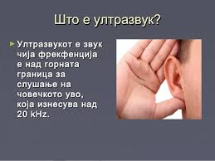 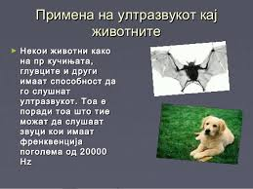

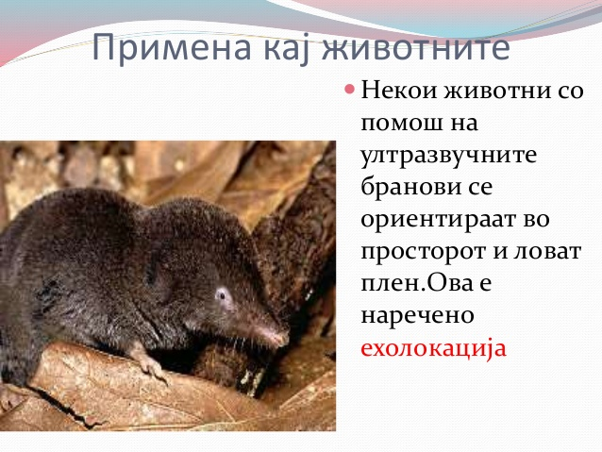

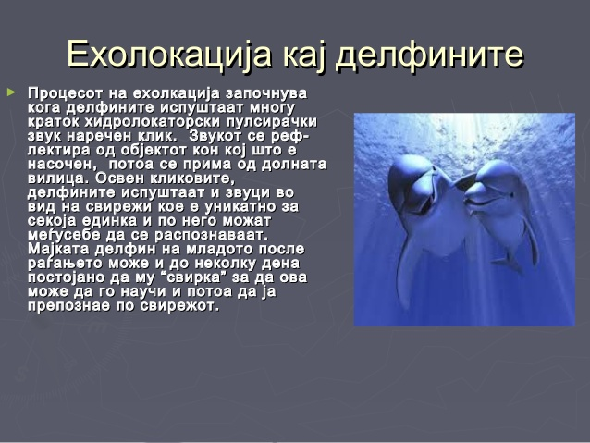

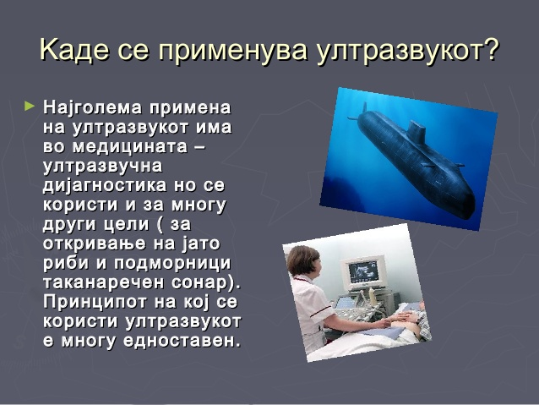

&Ucy;&lcy;&tcy;&rcy;&acy;&zcy;&vcy;&ucy;&kcy;&ocy;&tcy; &icy; &gcy;&icy;&ncy;&iecy;&kcy;&ocy;&lcy;&ocy;&gcy;&icy;&jsercy;&acy;&tcy;&acy;&Ucy;&lcy;&tcy;&rcy;&acy;&zcy;&vcy;&ucy;&kcy;&ocy;&tcy; &icy; &gcy;&icy;&ncy;&iecy;&kcy;&ocy;&lcy;&ocy;&gcy;&icy;&jsercy;&acy;&tcy;&acy;
► &Gcy;&icy;&ncy;&iecy;&kcy;&ocy;&lcy;&ocy;&shcy;&kcy;&icy;&Gcy;&icy;&ncy;&iecy;&kcy;&ocy;&lcy;&ocy;&shcy;&kcy;&icy;
&ucy;&lcy;&tcy;&rcy;&acy;&zcy;&vcy;&ucy;&kcy; &scy;&iecy; &vcy;&rcy;&shcy;&icy;&ucy;&lcy;&tcy;&rcy;&acy;&zcy;&vcy;&ucy;&kcy; &scy;&iecy; &vcy;&rcy;&shcy;&icy;
&zcy;&acy; &dcy;&acy;...

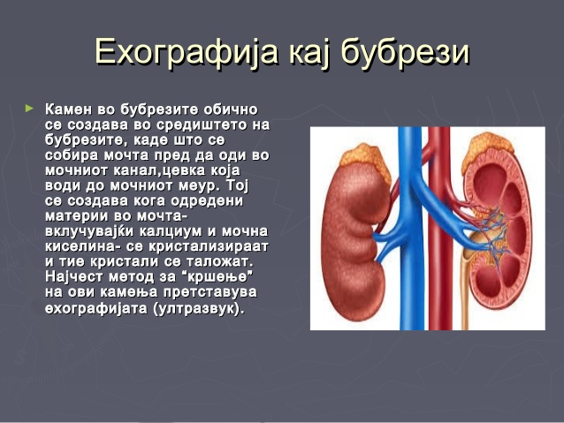

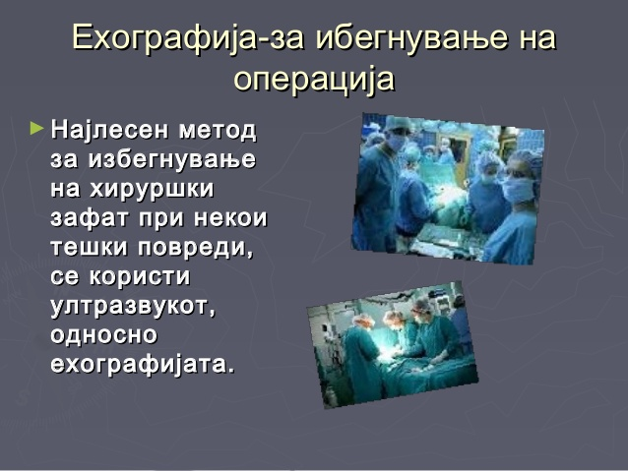

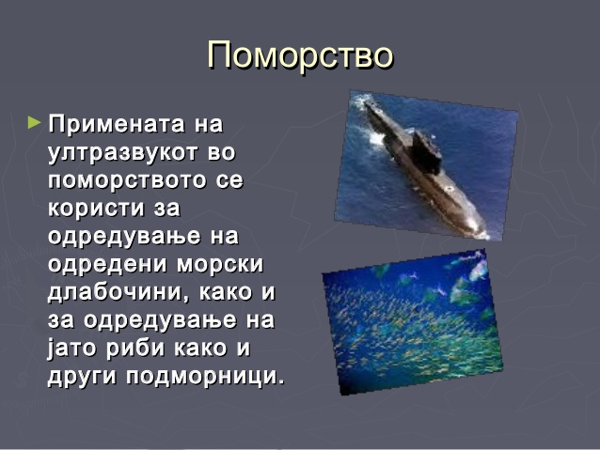

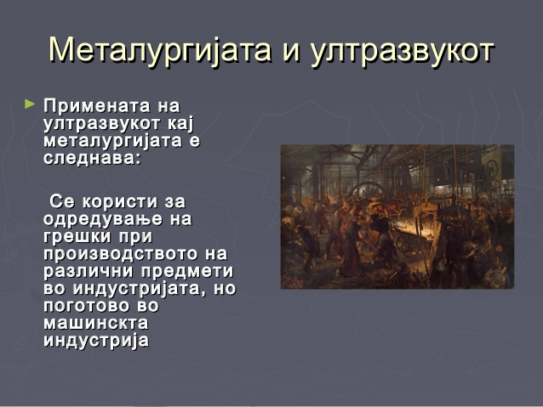

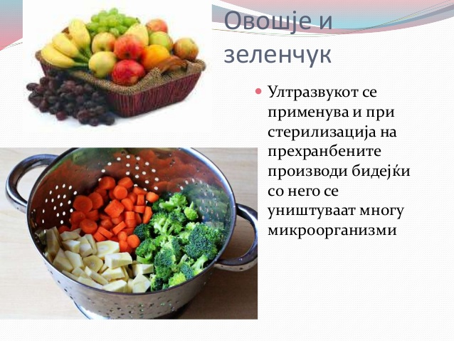

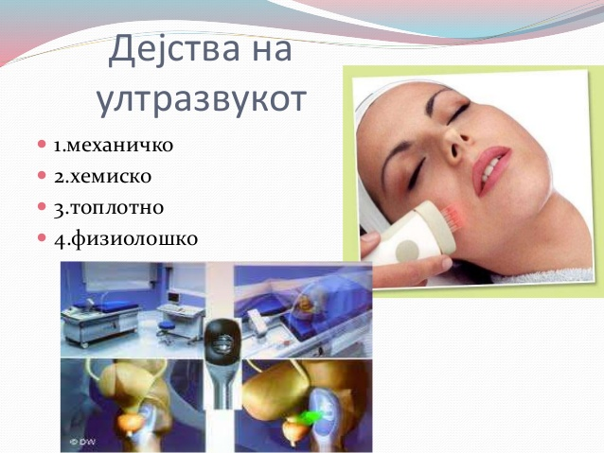

За дома:

Да се истражи ехологацијата кај животните

1. Како лилјаците комуницираат и ги лоцираат своите жртви
2. Како делфините комуницираат и ги лоцираат своите жртви